# **Name: Abdurrahman Qureshi**

# **Roll No: 210451**

Practical No: 10

1. **Designing – Combo Box and List Box**

**CODE:**

Public Class Form1

Private Sub Button1_Click(sender As Object, e As EventArgs) Handles Button1.Click

Dim count As Integer

Label4.Text &= ComboBox1.SelectedItem.ToString()

For Each element In ListBox1.SelectedItems

Label3.Text &= element & vbCrLf & " "

Next

End Sub

Private Sub Form1_Load(sender As Object, e As EventArgs) Handles MyBase.Load

Me.BackColor = Color.FromArgb(30, 30, 30)

Me.Font = New Font("Comic Sans MS", 14.0)

Me.Text = "EXP10ListBoxNComboBox"

Label1.ForeColor = Color.AntiqueWhite

Label2.ForeColor = Color.AntiqueWhite

Label3.ForeColor = Color.AntiqueWhite

Label4.ForeColor = Color.AntiqueWhite

End Sub

End Class

**OUTPUT:**

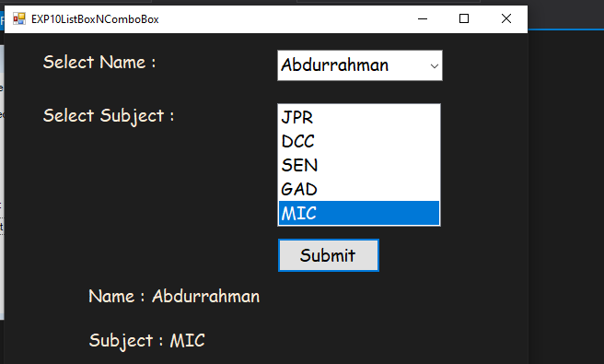

1. **Designing – Combo Box and List Box**

**CODE:**

Public Class Form1

Private Sub Button1_Click(sender As Object, e As EventArgs) Handles Button1.Click ListBox1.Items.Add(InputBox("Enter A Value : "))

End Sub

Private Sub Button3_Click(sender As Object, e As EventArgs) Handles Button3.Click

If ListBox1.Sorted Then

Button3.Text = "Unsort"

ListBox1.Sorted = False

Else

Button3.Text = "Sort"

ListBox1.Sorted = True

End If

End Sub

Private Sub Button4_Click(sender As Object, e As EventArgs) Handles Button4.Click ListBox1.Items.Remove(ListBox1.SelectedIndex)

End Sub

Private Sub Button5_Click(sender As Object, e As EventArgs) Handles Button5.Click

ListBox1.Items.Clear()

End Sub

Private Sub Button6_Click(sender As Object, e As EventArgs) Handles Button6.Click

MsgBox("Count : " & ListBox1.Items.Count)

End Sub

Private Sub Form1_Load(sender As Object, e As EventArgs) Handles MyBase.Load

Me.BackColor = Color.FromArgb(29, 29, 29)

Me.Font = New Font("Comic Sans MS", 10.0)

Me.Text = "EXP10ListBoxControls"

End Sub

End Class

**OUTPUT:**

